**IDEATION PHASE**

**EMPATHY MAP**

|  |  |
| --- | --- |
| **Date** | 5 October 2022 |
| **Team ID** | PNT2022TMID47589 |
| **Project Name** | Personal Assistance for Seniors who are Self-Reliant |
| **Maximum Marks** | 4 Marks |

**EMPATHY MAP CANVAS;**

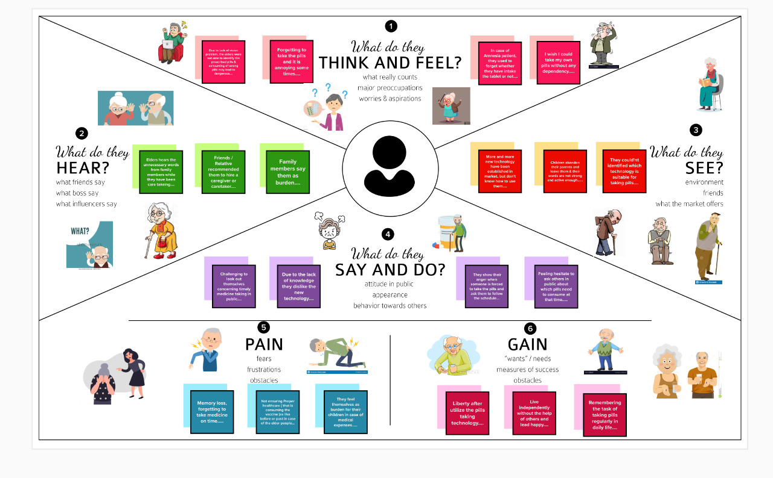

Reference Link : https://app.mural.co/invitation/mural/solamalai4412/1664704436746?sender=ufe3c1e1f6040a2d8c0685732&key=0d75eb76-20ca-45e7-b3ed-f65943b71e25